|  |
| --- |
| EPAM Systems, RD Dep. |
| MTN.BI.08 Materialized Views |

|  |  |  |  |  |  |
| --- | --- | --- | --- | --- | --- |
| REVISION HISTORY | | | | | |
| Ver. | Description of Change | Author | Date | Approved | |
| Name | Effective Date |
| 1.0 | Initial status | [Hanna](mailto:Kiryl_Bucha@epam.com) Takushevich | 29-NOV-2017 |  |  |

Contents

1. Materialized Views- Basic 3

1.1. Create Materialized Views - ON DEMAND 3

1.2. Create Materialized Views - ON COMMIT 5

2. Fact Table Loading 6

3. Task Results 6

# Materialized Views- Basic

## Create Materialized Views - ON DEMAND

Take any "report" SQL from Lab Work 02 and create Materialized View based on it. Refresh type is ON DEMAND.

* Use Standard CREATE MATERIALIZED VIEW CLAUSE.
* Use DBMS_MVIEW package to refresh Mat View.

Звезда для второго задания:

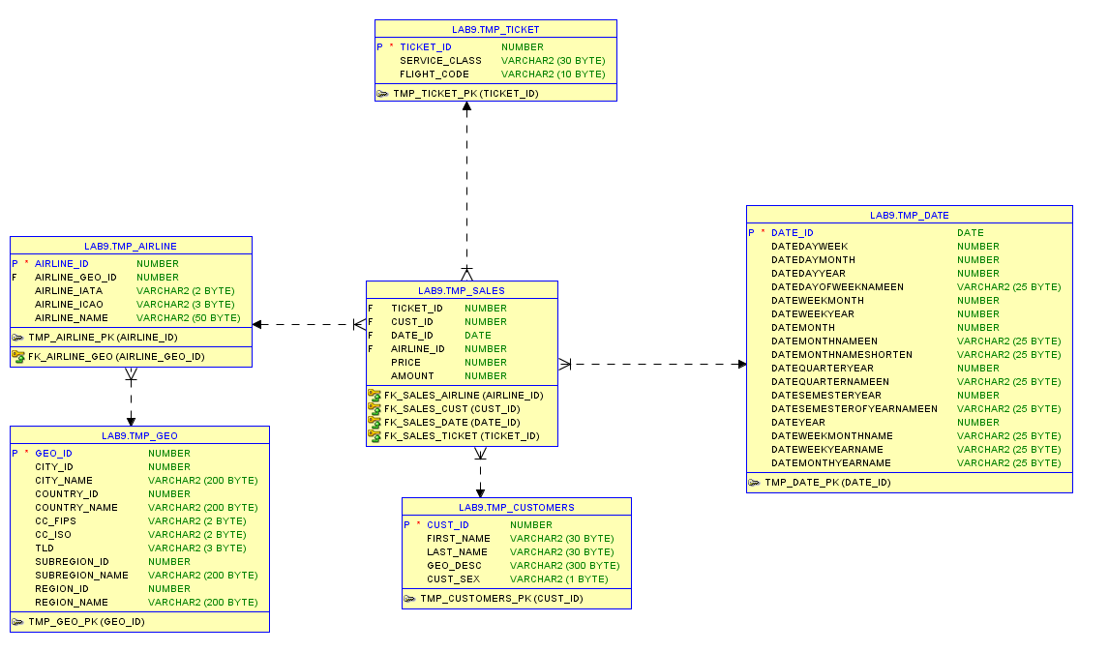

Составленный отчёт:

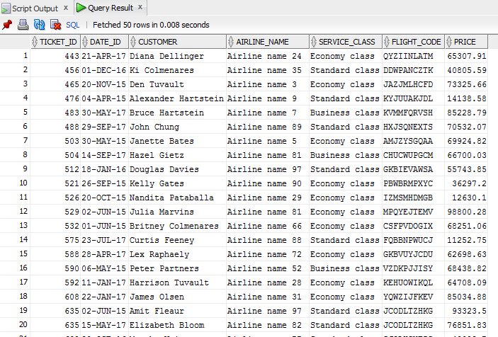

Скрипт для создания материального представления:

CREATE materialized VIEW mv_on_demand REFRESH ON DEMAND

AS

SELECT tmp_sales.ticket_id,

tmp_sales.date_id,

first_name

||' '

||last_name AS customer,

airline_name,

service_class,

flight_code,

price

FROM tmp_sales

JOIN tmp_customers

ON tmp_sales.cust_id = tmp_customers.cust_id

JOIN tmp_airline

ON tmp_sales.airline_id=tmp_airline.airline_id

JOIN tmp_ticket

ON tmp_sales.ticket_id=tmp_ticket.ticket_id;

Для проверки обновления материального представления добавим в таблицу tmp_sales строку:

select * from tmp_sales where price = 999999999999;

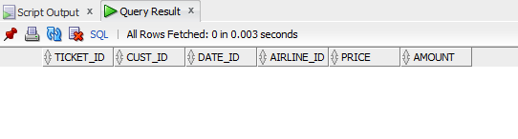

INSERT

INTO tmp_sales VALUES

(

1,

1,

to_date('23/03/2014', 'dd-mm-yyyy'),

1,

999999999999,

1

);

COMMIT;

SELECT * FROM tmp_sales WHERE price = 999999999999;

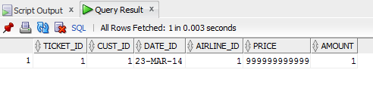

Проверяем, появилась ли эта строка в материализованном представлении:

select * from mv_on_demand where price=999999999999;

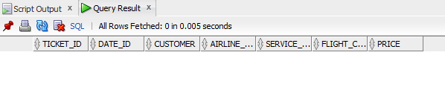

Обновляем материальное представление:

execute DBMS_MVIEW.REFRESH( 'mv_on_demand' );

Находим добавленную в таблицу tmp_sales строку в материальном представлении:

select * from mv_on_demand where price=999999999999;

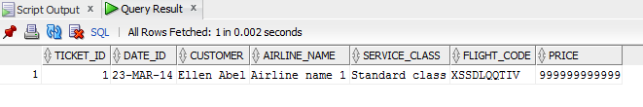

## Create Materialized Views - ON COMMIT

Take any "report" SQL from Lab Work 02 and create Materialized View based on it. Refresh type is ON COMMIT.

* Use Standard CREATE MATERIALIZED VIEW CLAUSE.
* Tests ON COMMIT REFRESH.

Создание лога:

CREATE MATERIALIZED VIEW LOG ON tmp_customers

WITH primary key,

ROWID,

SEQUENCE(first_name, last_name);

Создание материализованного представления:

CREATE materialized VIEW mv_on_commit REFRESH FAST ON COMMIT

AS

SELECT * FROM tmp_customers;

Поиск клиента с именем Hanna в таблице tmp_customers:

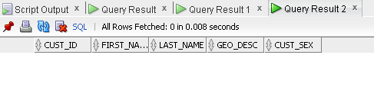

Вставили строку в таблицу tmp_customers, но не сделали коммит:

insert into tmp_customers values (200000, 'Hanna', 'Takushevich', 'Belarus, Minsk', 'F');

select * from mv_on_commit where first_name = 'Hanna'

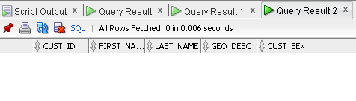

После коммита:

commit;

select * from mv_on_commit where first_name = 'Hanna';

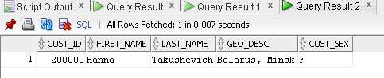

# Fact Table Loading

Create packages to load fact table to the presentation layer.

# Task Results

Create required objects:

* Put objects script to Git.
* Prepare Document with Screenshot of Tests Data.
* Prepare Document with Screenshot of Refreshing Mat View script.